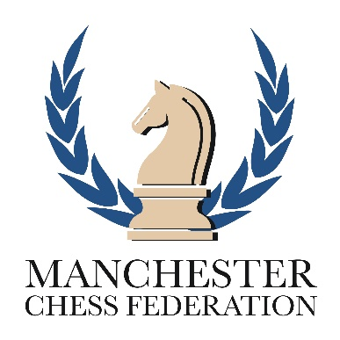

**MANCHESTER JUNIOR CHESS**

**Manchester EPSCA Team Trial**

Every year Manchester enters teams in the EPSCA Associations Championships. There are three teams, Under 11, Under 9 and an Under 11 Girls team. Children who wish to represent Manchester need to either attend the Manchester Trials or register to play.

M**anchester Juniors Trial**

**Where: Cleveland School**

425 Chorley New Road, Bolton, BL1 5DH

**When:**  **Saturday 1st February 2020**

10.30 a.m. to 4.30p.m. Bring a packed lunch

**Who:** Children who are under 11 years old and who are ether resident

in the Greater Manchester area or attend a school in the Greater Manchester area[1]

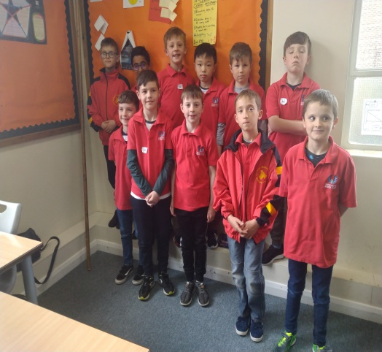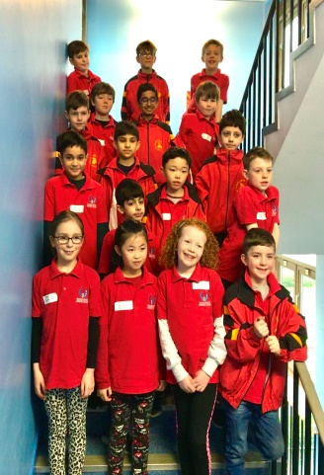

**Apply:** Send Name, Address, Date of Birth, School and email address to

julian.clissold@outlook.com

***Important.*** *If you cannot make 1st Feb, register as above and ensure you are considered.*

1. Children from Tameside and Oldham have their own Association Teams and should contact Steve Rigby ([nippy50@hotmail.com](mailto:nippy50@hotmail.com)) or Steve Mason ([stevemason9876@gmail.com](mailto:stevemason9876@gmail.com)) accordingly.